Microsoft Teams – Update – process
If you are asked to update your Teams follow the steps below
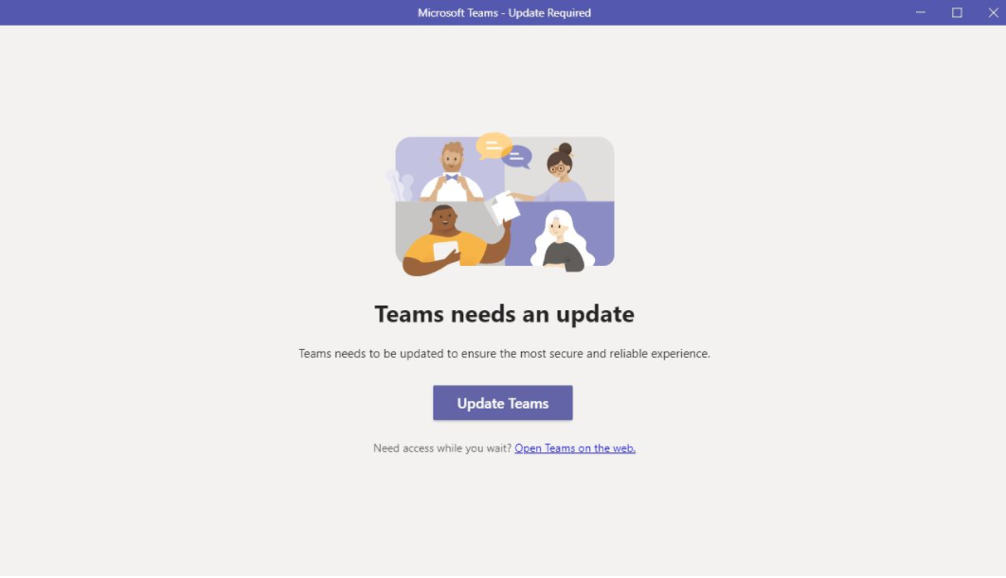
Step 1
Click ‘Update Teams’
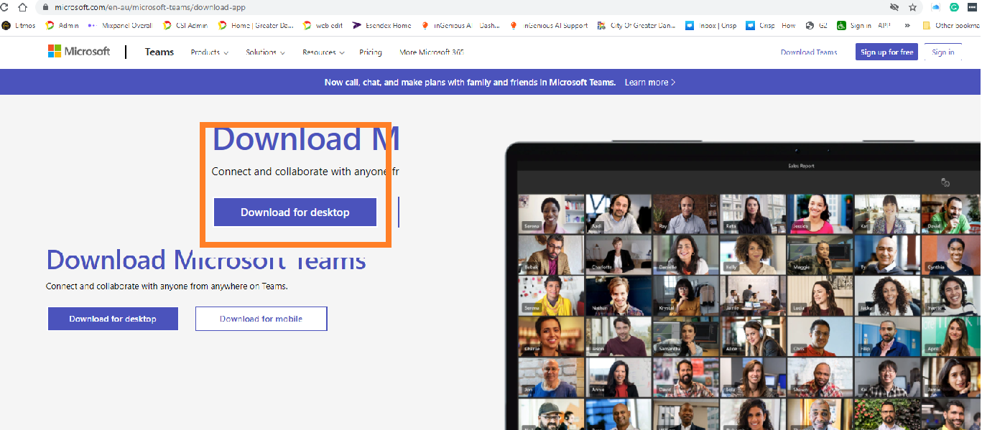
Step 2
Click ‘Download for desktop’
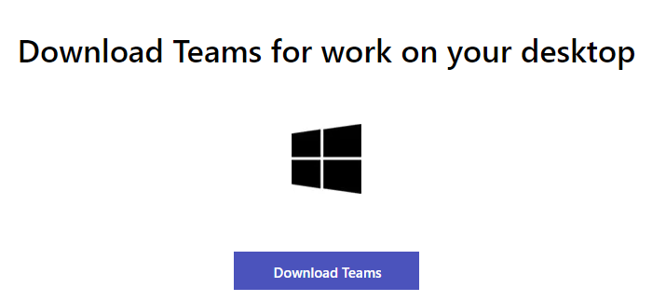
Step 3
Click ‘Download Teams’

Once downloaded
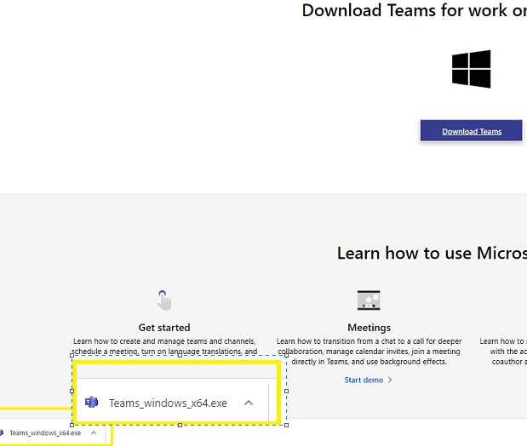
Step 4
Double click on the downloaded file to launch
Teams will then begin to install
