Troubleshooting - Sound, Puck, Teams and VRClient issues
There are a lot of working parts to make things work seamlessly. As such you may need to check all the troubleshooting steps to isolate where the problem may be.
- Sound issues
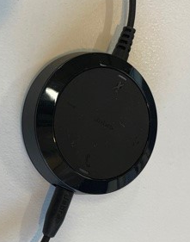
Step 1
Check there is only one puck (communication disc) connected to the computer
Step 2
Check your headset is connect to the puck

Step 3
Chick on the sound settings to make sure that the headset is recognised by the PC and it is selected

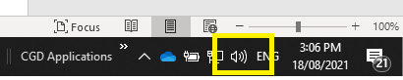

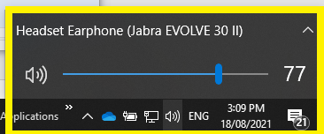
Step 4
Check that the headset/speakers are not muted

Note: If still not working, go to Communication Disk (Puck) troubleshooting – see below
- Sound Device Settings
If there is no sound or you can’t hear the caller the Jabra Headset may not be recognised, follow the steps below.

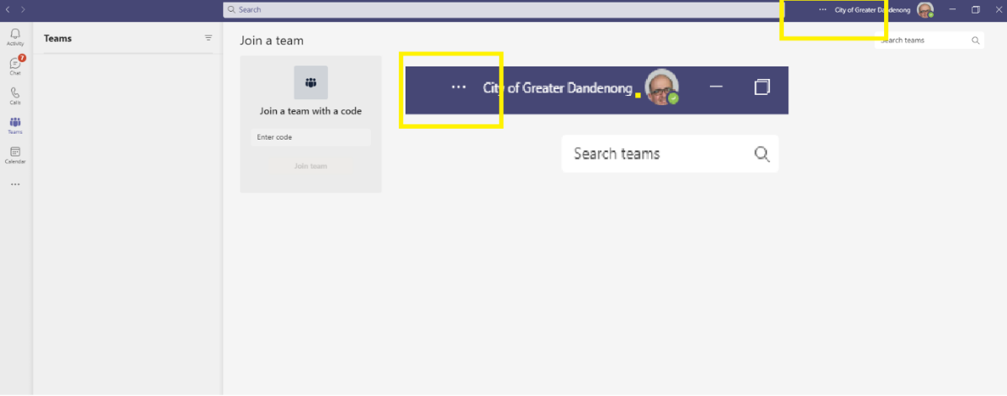
Step 1
Go to and click on the three dots before City of Greater Dandenong and your login picture

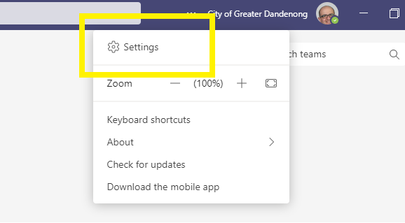
Step 2
Click Settings

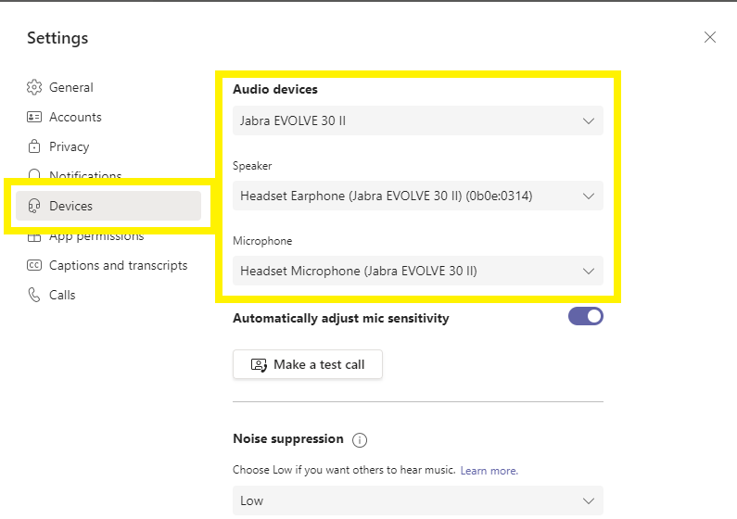
Step 3
Click Devices
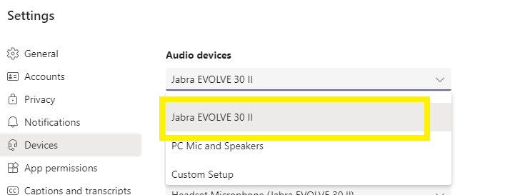
Step 4
Select the relevant Jabra device (could be listed as Polycom handset if you are on the counter)

Close the settings window

- PUCK (Headset Communication Disk) – No Sound
The Puck can become faulty of overtime and may not work at all. If this happens there will be no sound coming through.

- Check Headset/Puck is connected properly and that it shows up on the sound devices list (see Step 4 of * Sound Devices Settings or * Sound Issues)
- If not, try putting it into another USB input slot
Laptop USB input | Desktop USB input | Keyboard USB input
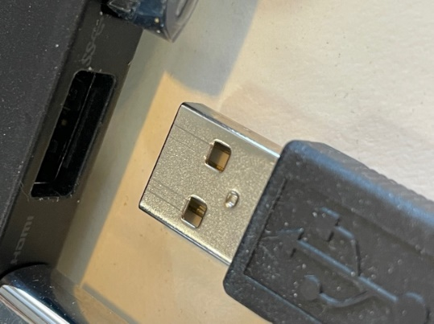 | 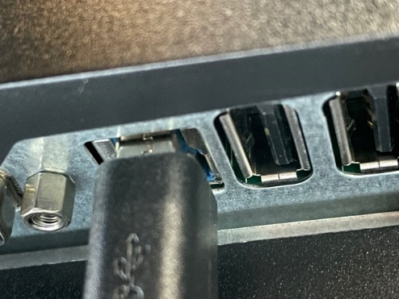 | 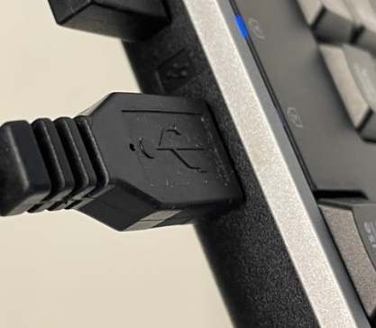

- If still not working replace the Puck with a new one

- VRClient error
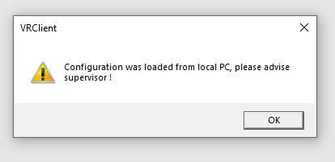
This error occurs when DiMetro (voice recording software) is not picking up the headset or is not able to connect to the Server.
  - Check Headset/Puck is connected properly and that it shows up on the sound devices list
  - The puck may be faulty and you will need to replace it.
Note: The puck may temporarily lose connection to the PC from time to time but if it is increasingly getting worse, it needs replacing.

