Microsoft Teams – Secondary Ringer - Setting
If you can’t hear the phone rings from your PC speakers follow the steps below

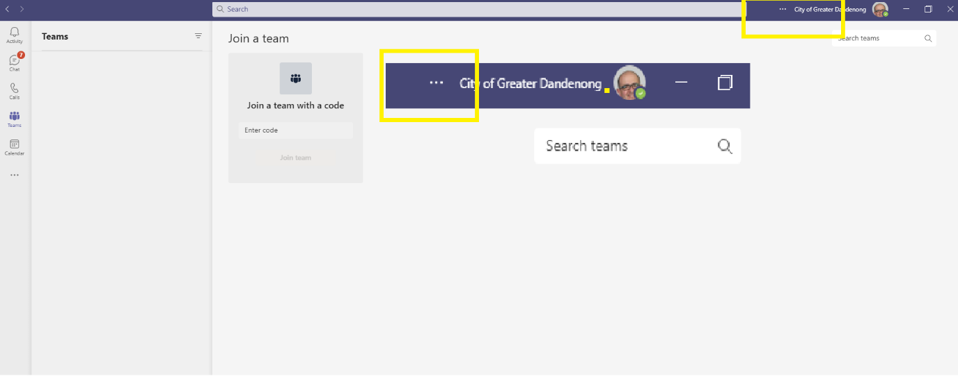
Step 1
Go to and click on the three dots before City of Greater Dandenong and your login picture

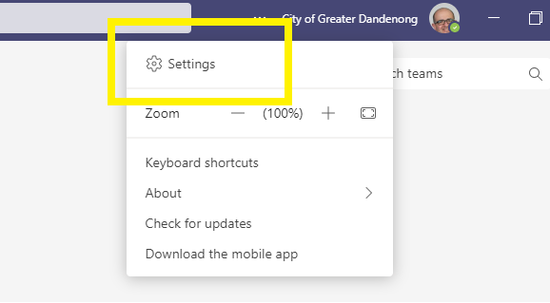
Step 2
Click Settings

Step 3
Select the relevant Jabra device (could be the Polycom handset if you are on the counter)

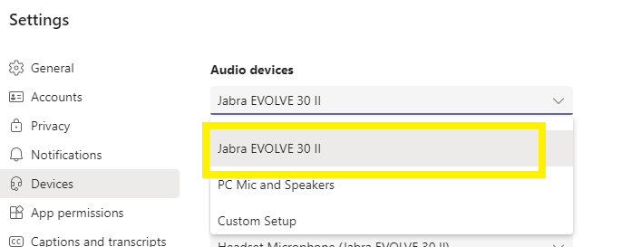

Close the settings window to finish

