Microsoft Teams - No Sound/Voice – Device Settings
If there is no sound or you can’t hear the caller the Jabra Headset may not be recognised, follow the steps below.

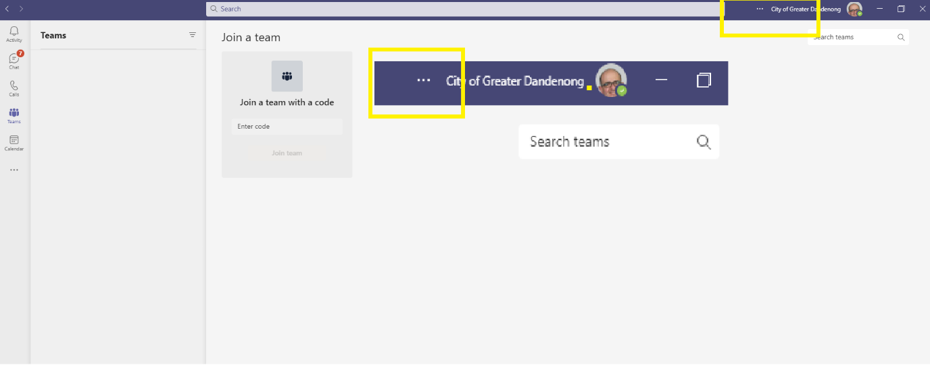
Step 1
Click on the three dots before City of Greater Dandenong and your login picture

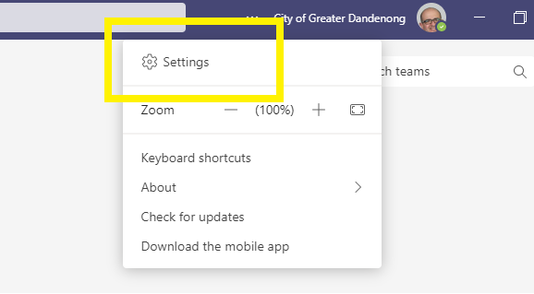
Step 2
Click Settings

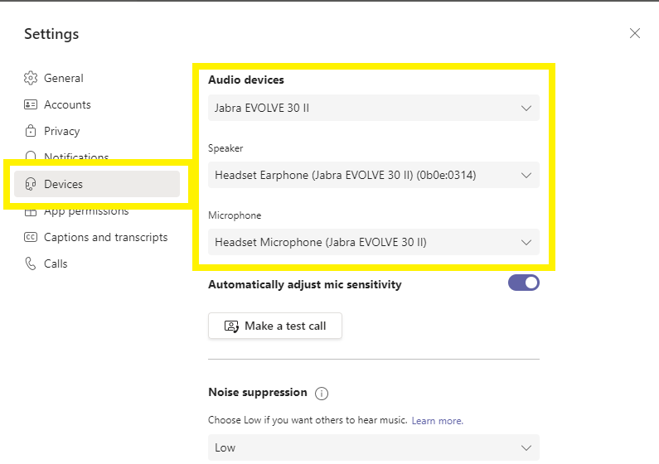
Step 3
Click Devices
Step 4
Select the relevant Jabra device (could be the Polycom handset if at the front counter)

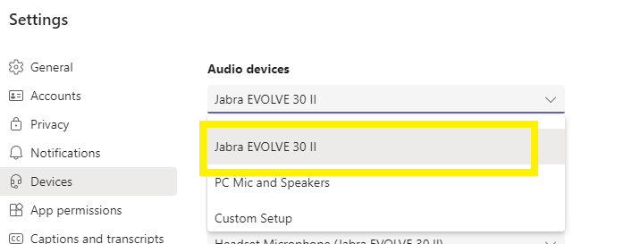

Close the settings window

